1. Be sure login to sql server under SQL SERVER AUTHENTICATION
2. If not have SQL username and password yet, follow this step:
3. Click on Server name -> Right click -> Properties  
   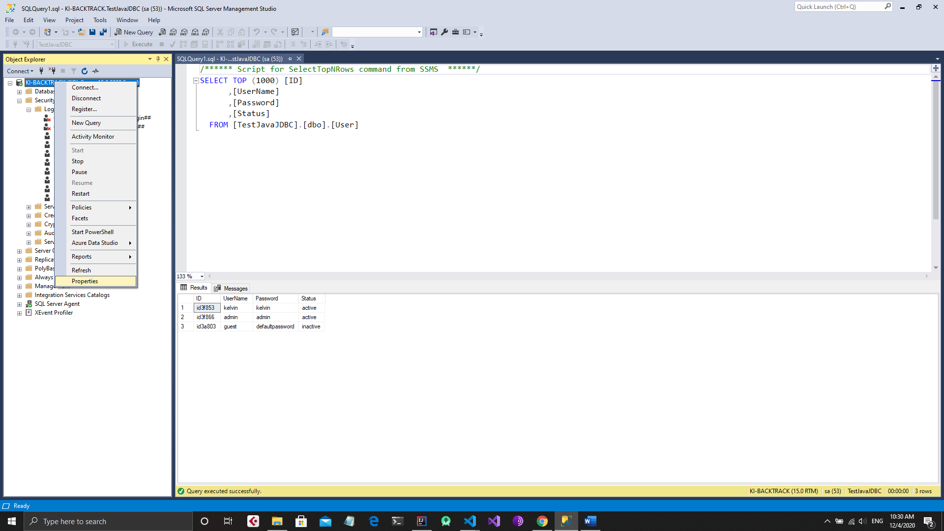  
     
   Check security field -> Enable SQL Auth and Windows Auth  
   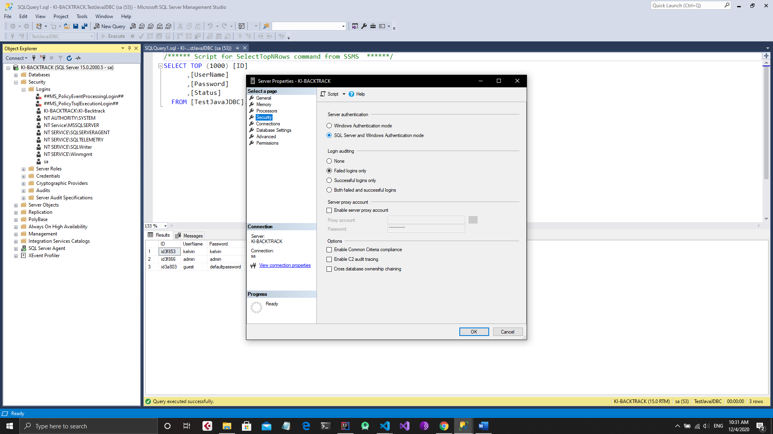
4. Click on security -> Login -> sa-> properties  
   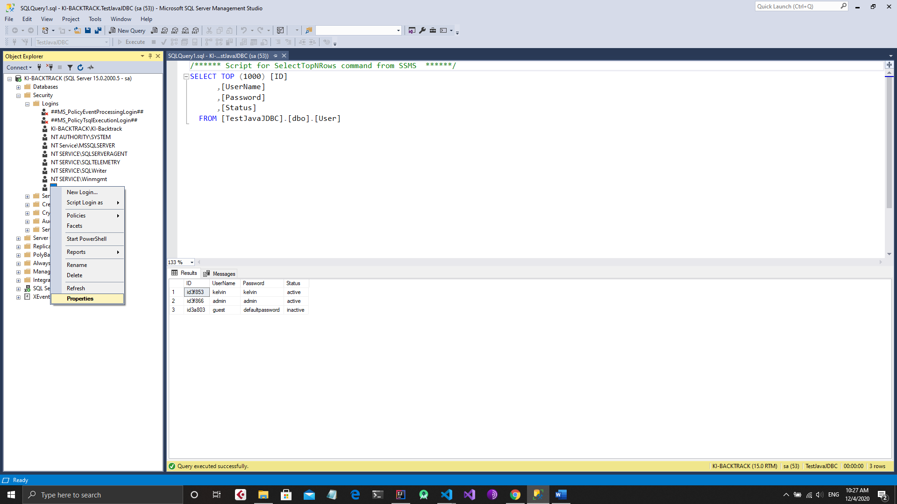
5. In General Reset Password and username  
   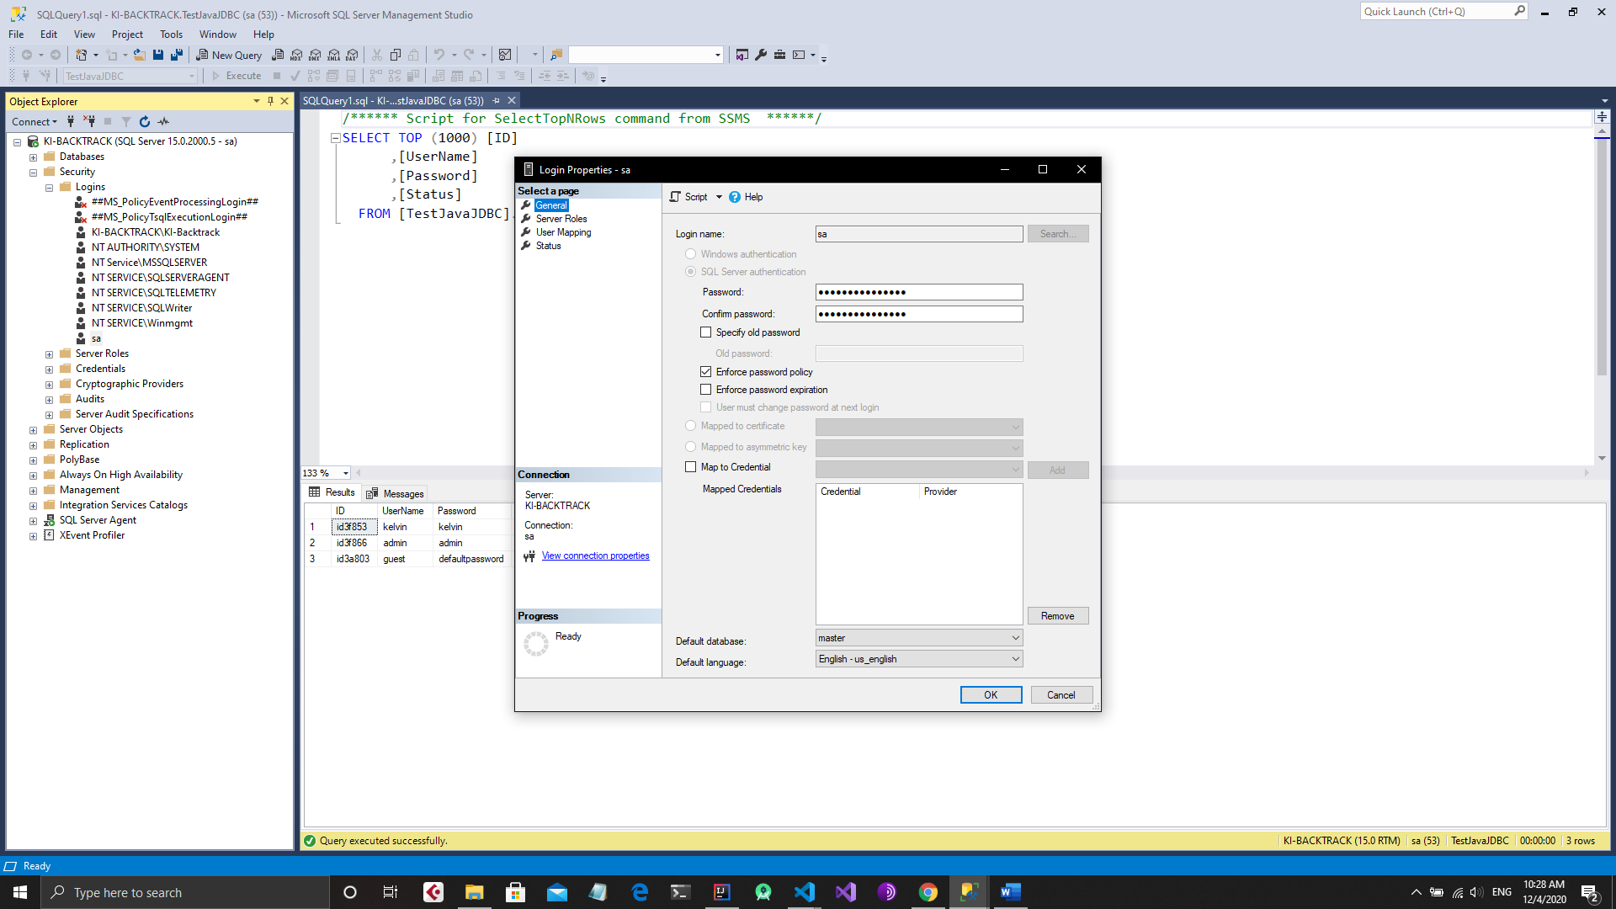
6. In Status -> Enable sa account -> OK
7. Restart SQL server by right click server name and restart.
8. OK the last step, check database.properties and replace username and password  
   